Thank you for contacting Environmental Health and Safety for an ergonomics review! You and your supervisor will receive solutions that reduce ergonomic risks and enhance your safety and productivity.
Let’s get started!
❶ Provide your contact information
First Name: |  | Last Name:
email: |  | Dept:
Phone: |  | Supervisor

❷ Complete the online ergonomics systems survey
It is a one-page form to help me to learn more about your situation. http://www.ehss.vt.edu/HazAssess/symptomsurvey.php
❸ Take images of your workstation
Ask your supervisor or co-worker to take images while you are using your workstation as you normally do. It is important that the images represent how you typically interact with your workstation. This includes equipment placement, posture, and yes, even clutter! Just don’t include anything of a confidential nature in the images. If possible, convert images into screen resolution for smaller file sizes.
❹ Save your images in this document
Place all images in this document and comments, then, save it as “your last name, first name”.
❺ Encrypt and email this document to ergo@vt.edu
Encrypt (recommended but not required) and email this document as an attachment to ergo@vt.edu with a subject line of “Workstation Images for <insert your name here>”. Please do not send individual attachments of images. Include all images in this one document to avoid evaluation delays.
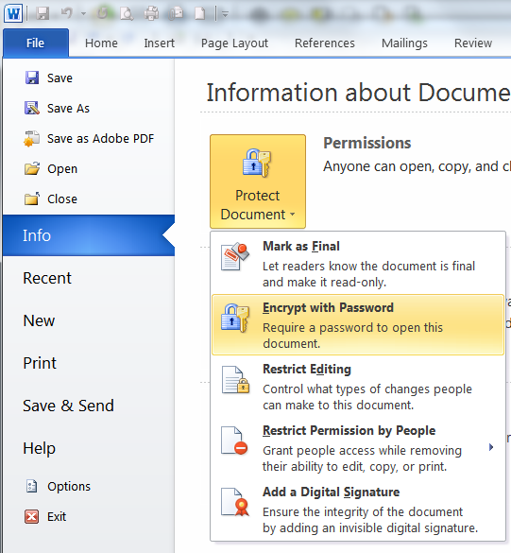
Here is how you can quickly encrypt your file in Word. However, if you choose to encrypt you must remember the password
If you choose to encrypt, you must send me the password in a separate email or provide it over phone at 231-3080. Without the password, your file cannot be read.

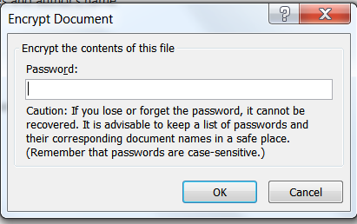

❻ Allow time for risk analysis and solutions
Due to the volume of requests, please allow 2 weeks for risk analysis and solutions. I will contact you with any questions I have. This usually is via email, but a scheduled phone call may be necessary to clarify issues and solution options.
❼ Write or call
Please feel free to write me at ergo@vt.edu or call me at 231-3080 if you have any questions or comments about this process. I would be glad to continue to offer any assistance you may need to improve the ergonomics of your area to make a safer and healthier workplace.

Workplace Images
NOTE: Please place all images into this document. Do not send individual attachments.
1. Vacant workstation
Show the workstation by itself without the chair or person (landscape).
<insert image1>

2. Vacant chair
Show the empty chair from the right side (portrait).
<insert image2>

3. In chair
Be seated in the chair as you would normally use it.
< insert image3>

4. Back
While you are using the workstation, have someone stand behind you and take your picture with the back of your head centered.
< insert image4>

5. Left
While you are using the workstation, have someone take your picture from your left side.
< insert image5>

6. Right
While you are using the workstation, have someone take your picture from your right side.
< insert image6>

7. Keyboarding
Take while both hands are using the keyboard (not posed).
< insert image7>

8. Mousing
Take while hand is using the mouse (not posed).
< insert image8>

9. Other workplace views you think would help in the analysis. (Optional)

